Employers Confederation of the Philippines (ECOP)

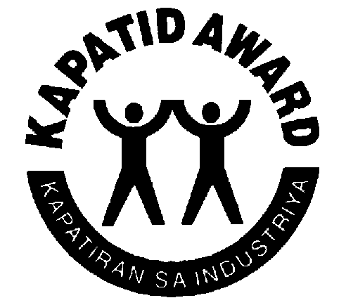 ^{THE 2019 KAPATID AWARDS}

APPLICATION FORM

Date: _______________________

Sir / Madam:

Our Company ________________________________________________ hereby expresses
(Name of Company)
interest to participate and vie for the 2019 KAPATID Awards.

We agree to:
- Abide by the rules and regulations of the KAPATID Awards;
- Submit supporting documents on our programs / activities consistent with the criteria;
- Constitute a delegation of management and employees’ representatives during the screening interviews of the Executive Committee and Board of Judges;

We understand that the Awards Executive Committee and/or Secretariat have the power to nullify or reject our application, even if already selected or included as finalist, for failure to abide by the agreements set forth in this application.

_____________________________________________
Name and Signature of President / CEO/Authorized Officer

Company Address: _______________________________________________________

Contact Person for the Award: ______________________________________________

Telephone: _______________________________ Fax: __________________________

Email: _________________________________________________________________

Please fax this form to the ECOP Research and Advocacy Department at 895-8576 or email to marianne.rosas@ecop.org.ph or research@ecop.org.ph .

